Name of Member

Member

September 1, 2018 – August 31, 2028

National Association of Case Management

Members of the National Association of Case Management ascribe to advancing the professional growth of individuals who provide
case management and service coordination.
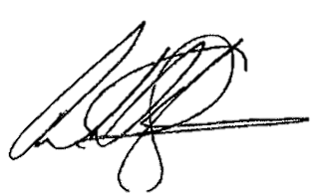

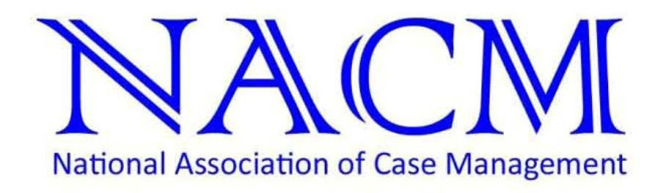
Ervin R. Munro, M.S.
Chair, Membership Committee
C.J. Johnson, LMHP, LCSW
Board Chair, NACM

